QATAR WORLD CUP 2022
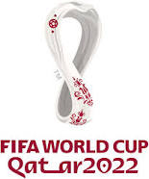

Write a one page paper stating your opinion on whether it was the correct decision to be holding the World Cup in Qatar. You must back up your opinions with facts from the booklet, articles, Netflix documentary, and any of your own research. Please use MLA for all works citied! Your paper must be typed and single spaced.

